**Olympic Data Analytics**

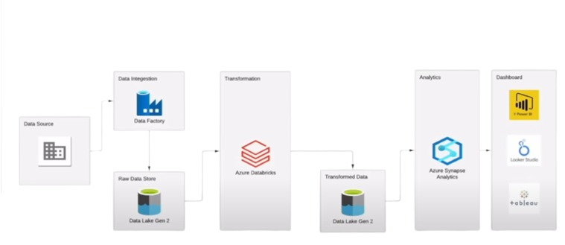

Data Source Link:

🡪 https://www.kaggle.com/datasets/arjunprasadsarkhel/2021-olympics-in-tokyo

1. Data Source: Kaggle / GitHub

Description: The raw data originates from the "Tokyo 2021 Olympics" dataset hosted on Kaggle. For easier access via API, the files (Athletes, Coaches, Entries, Gender, Medals, Teams) are converted to CSV and uploaded to a GitHub repository. The project uses the raw CSV URLs from GitHub as the source for data ingestion.

* Role in Project:
* Acts as the initial source system, simulating data coming from an external API or web source.

2. Azure Data Factory (ADF)

Description: Azure's cloud-based data integration service (ETL/ELT). It is used to create, schedule, and orchestrate data pipelines. In this project, it's the primary tool for data ingestion.

* Role in Project:
* Ingestion Pipeline: Creates a pipeline with a "Copy Data" activity.

HTTP Connector: Connects to the raw CSV files on GitHub (the data source) using the HTTP linked service.

Azure Data Lake Gen2 Connector:

* Connects to the target Azure Data Lake Storage Gen2 account.

Orchestration:

* Copies each CSV file from the GitHub source to the "raw" container in the data lake without transformation.

3. Azure Data Lake Storage Gen2 (ADLS Gen2)

Description: A massively scalable and secure data lake for high-performance analytics workloads. It combines the power of a hierarchical file system with the cost-effectiveness of Azure Blob Storage.

* Role in Project:
* Raw Data Storage: The raw-data directory stores the original, unaltered CSV files ingested by ADF.

Transformed Data Storage: The transform-data directory stores the processed data (in CSV format) after transformation by Azure Databricks.

* Acts as the centralized storage layer for both the bronze (raw) and silver (transformed) layers of the data lake architecture.

4. Azure Databricks

Description: A unified data analytics platform optimized for the Azure cloud, built on top of Apache Spark. It provides a collaborative environment for running large-scale data engineering and data science workloads.

* Role in Project:
* Data Transformation: The core transformation logic is written in PySpark (Python API for Spark) within a Databricks notebook.

Mounting ADLS: The notebook code mounts the ADLS Gen2 storage account to the Databricks file system (DBFS) using Azure Active Directory (AAD) authentication via an App Registration (Service Principal).

Data Processing:

* Reads the raw CSV files from the mounted location, performs schema inference/enforcement (e.g., casting string columns to integer), and writes the transformed data back to the transform-data directory in ADLS Gen2.

5. Azure Synapse Analytics

Description: An integrated analytics service that brings together big data and data warehousing. It allows you to run both serverless and dedicated SQL queries on your data in the data lake.

* Role in Project:
* (Mentioned in the architecture but its detailed execution is in Part 2). It is used to run SQL queries on the transformed data stored in ADLS Gen2 to perform analysis and gain insights (e.g., "find the top countries with the highest gold medals").

6. Programming & Query Languages

PySpark:

* primary language used within the Azure Databricks notebook for data transformation. It leverages the distributed processing power of Apache Spark.

SQL:

* Used within Azure Synapse Analytics to analyze the transformed data.

7. Azure Active Directory (AAD) / App Registration

Description: Microsoft's cloud-based identity and access management service. An App Registration (Service Principal) is created to provide a secure identity for Azure Databricks to access Azure Data Lake Storage Gen2.

* Role in Project:
* Provides the authentication mechanism (Client ID, Tenant ID, Client Secret) used in the Databricks notebook to mount the ADLS Gen2 account, ensuring secure access without hard-coding credentials in a production environment (though done here for tutorial simplicity).

8. Azure Resource Group

Description: A container that holds related resources for an Azure solution. It simplifies management by grouping all project resources (Storage, Data Factory, Databricks, etc.) together.

* Role in Project:
* All services (Storage Account, Data Factory, Databricks Workspace) are deployed under a single Resource Group named Tokyo-Olympic for easy management, cost tracking, and cleanup.

Summary of the Data Pipeline Flow:

* Ingest (ADF): Data is copied from GitHub → ADLS Gen2 (raw).
* Store (ADLS Gen2): Data sits in the raw-data folder.

Transform (Databricks):

* A PySpark n

otebook reads the raw data, processes it, and writes it back to → ADLS Gen2 (transform).

Analyze (Synapse Analytics):

* SQL queries are run on the transformed data to generate insights.

Visualize (Power BI/Tableau):

* (Implied final step) The analyzed data can be connected to a visualization tool to build dashboards.

This project demonstrates a modern cloud-native data pipeline on Microsoft Azure, leveraging key services for ingestion, storage, processing, and analysis.

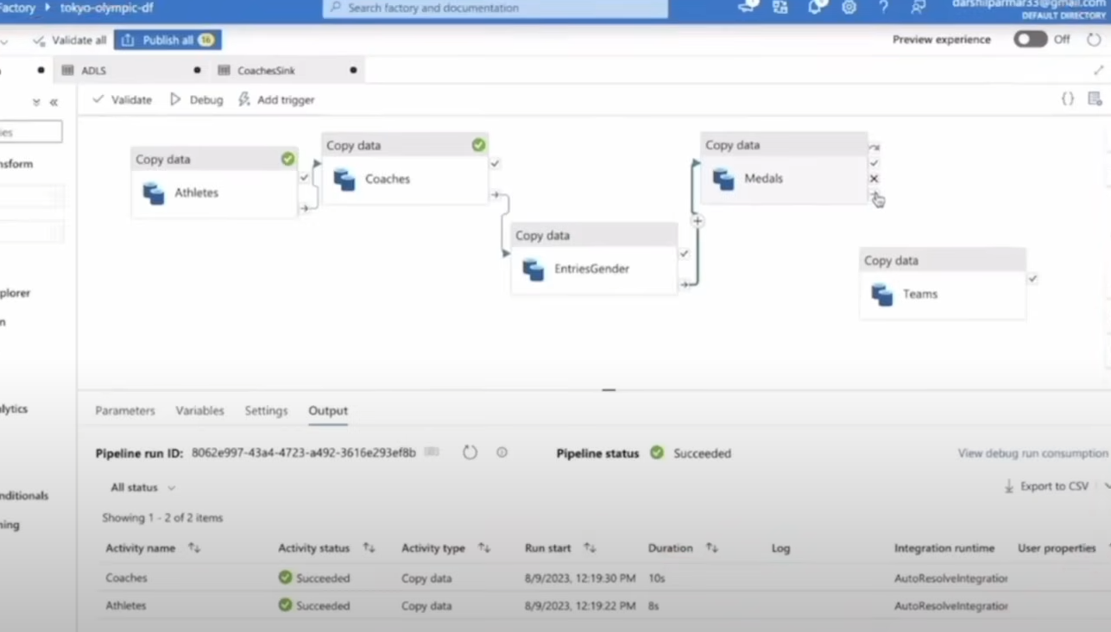

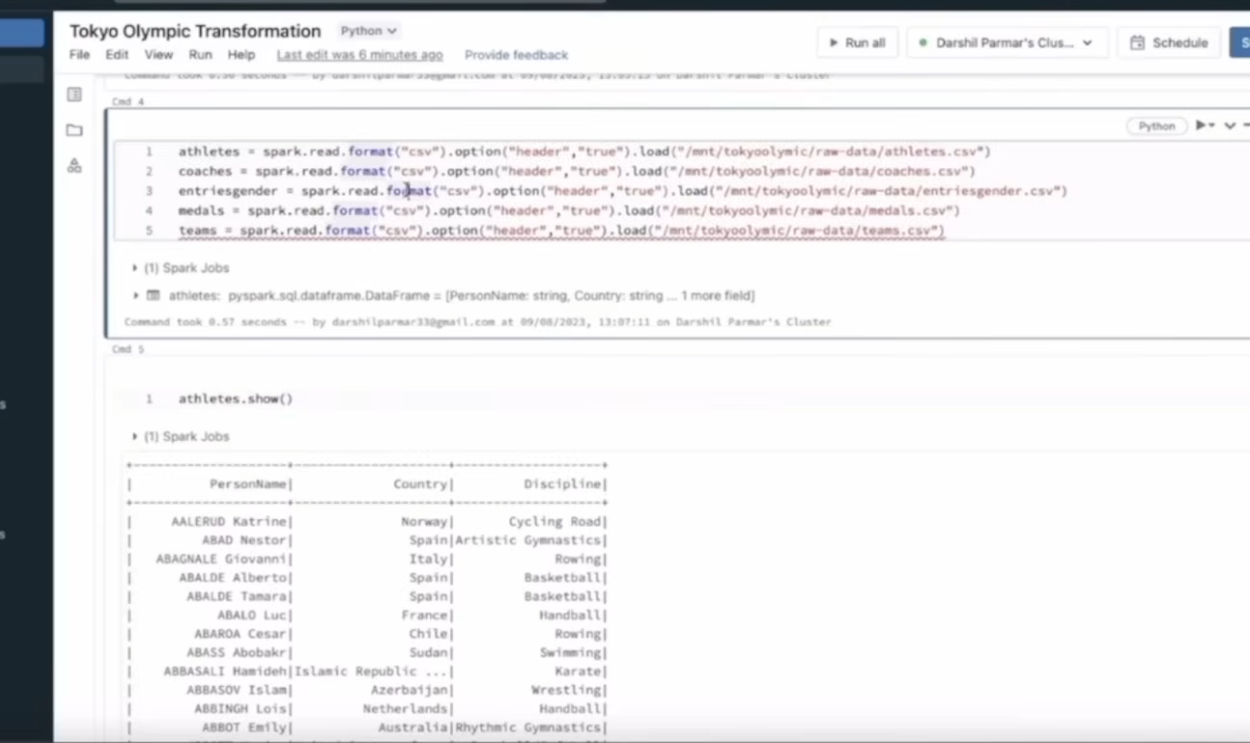

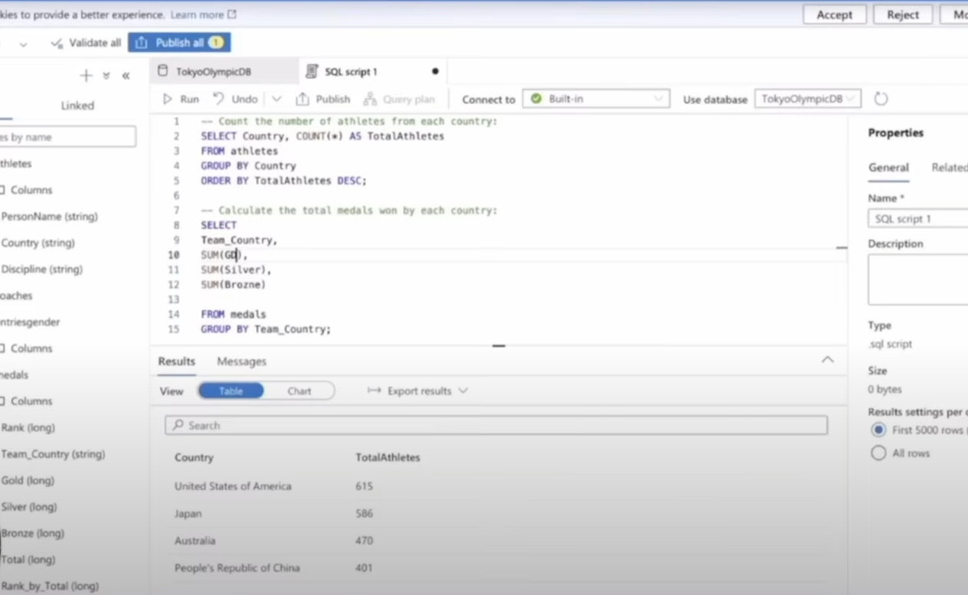

Create Storage account

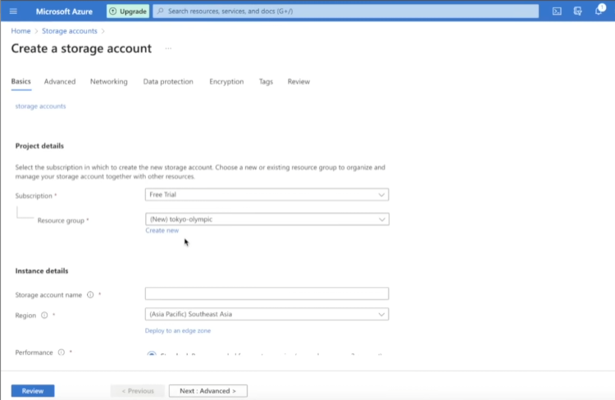

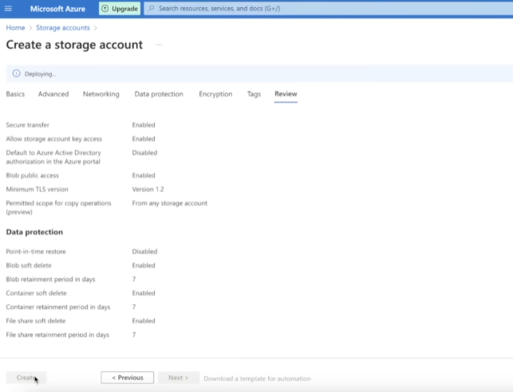

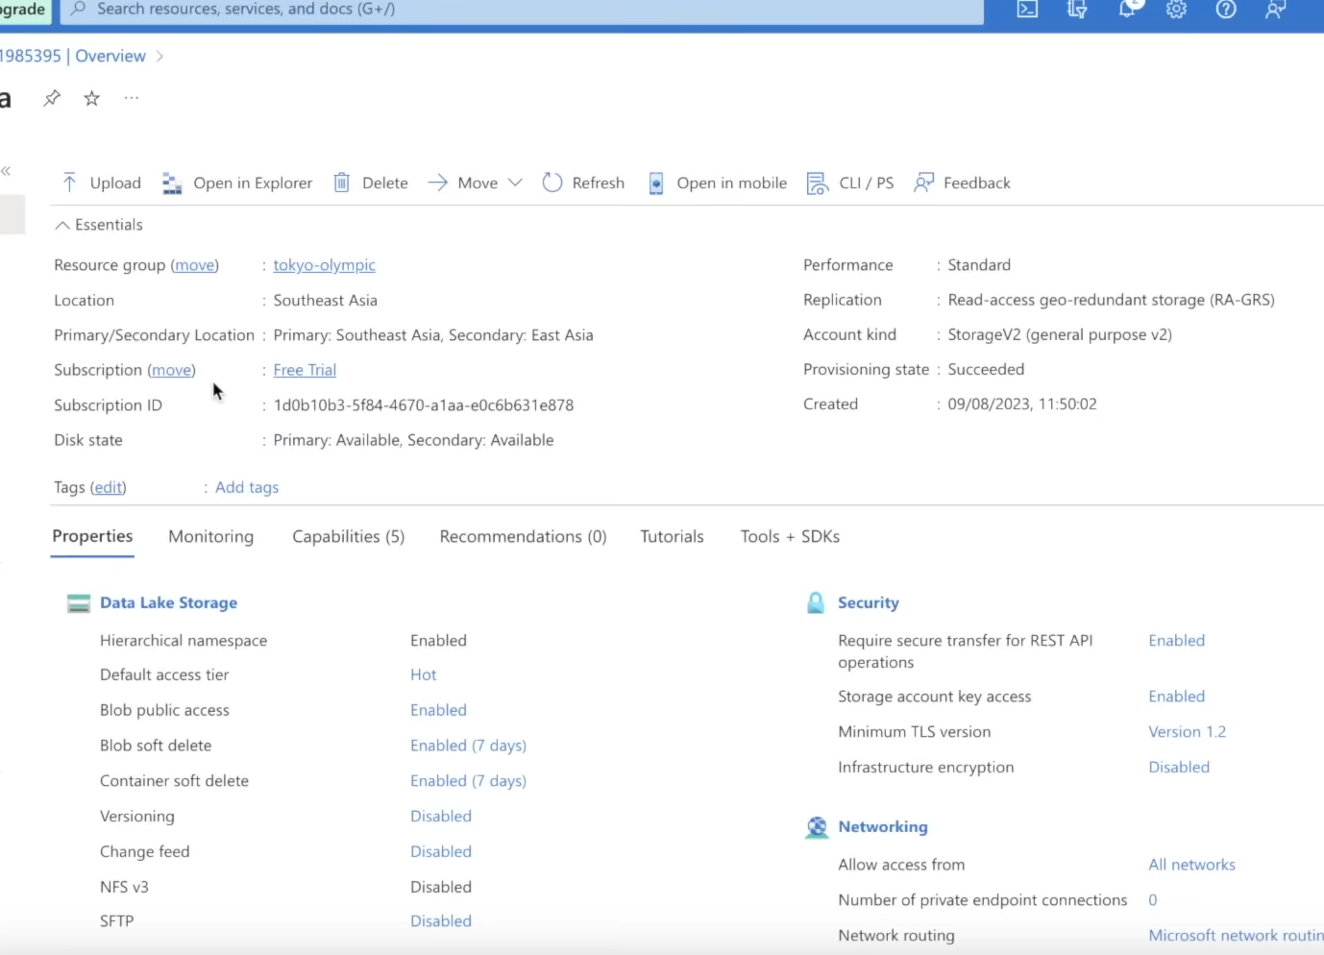

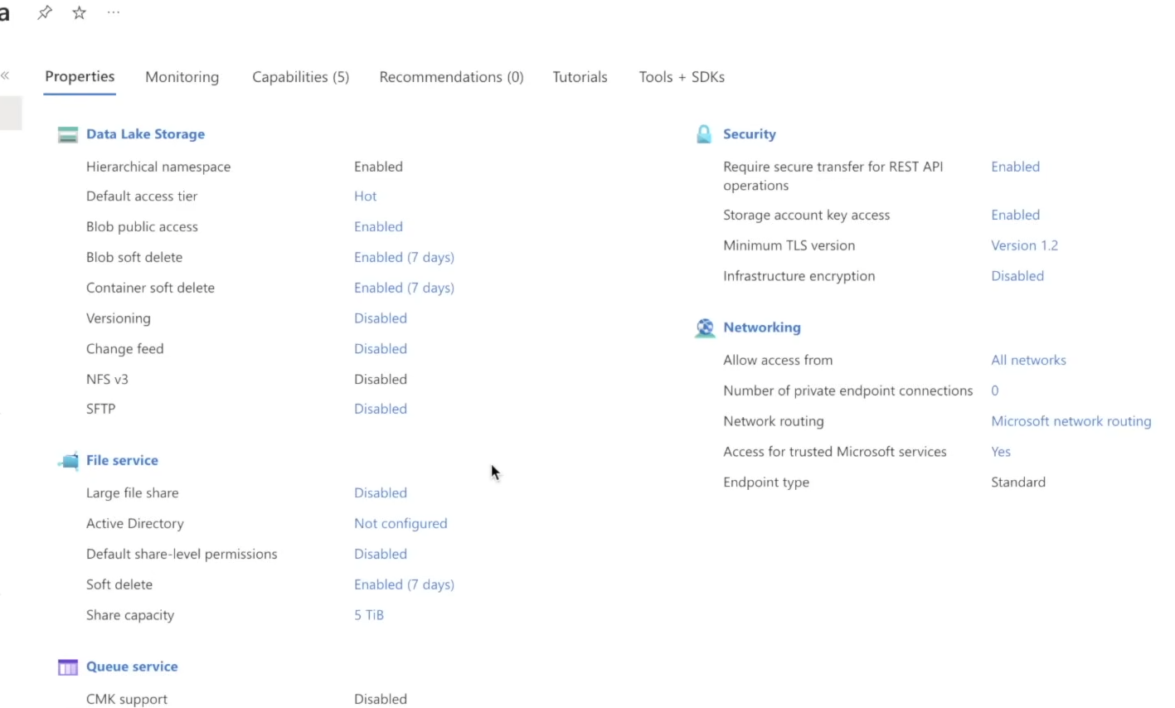

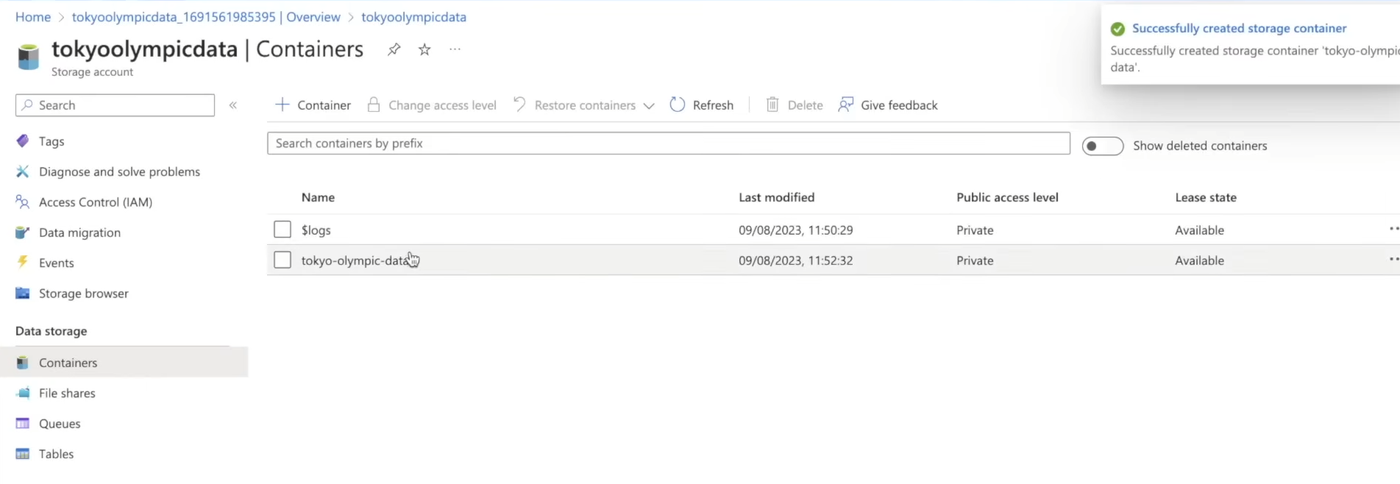

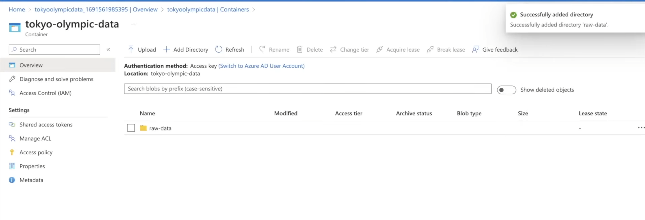

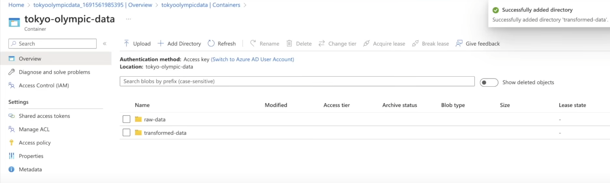

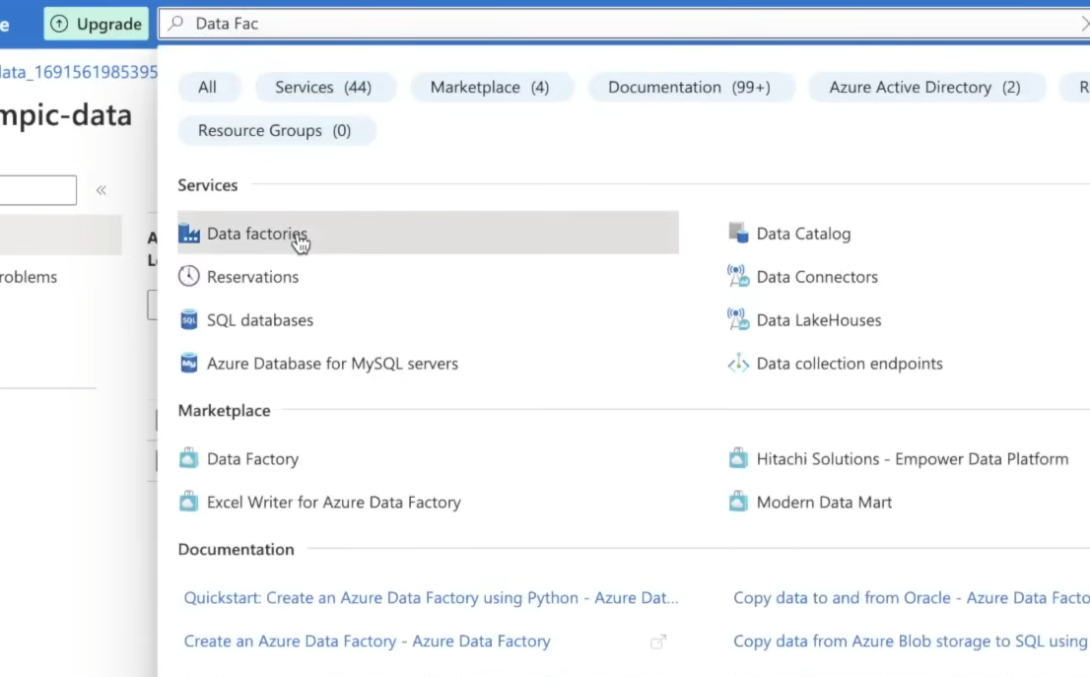

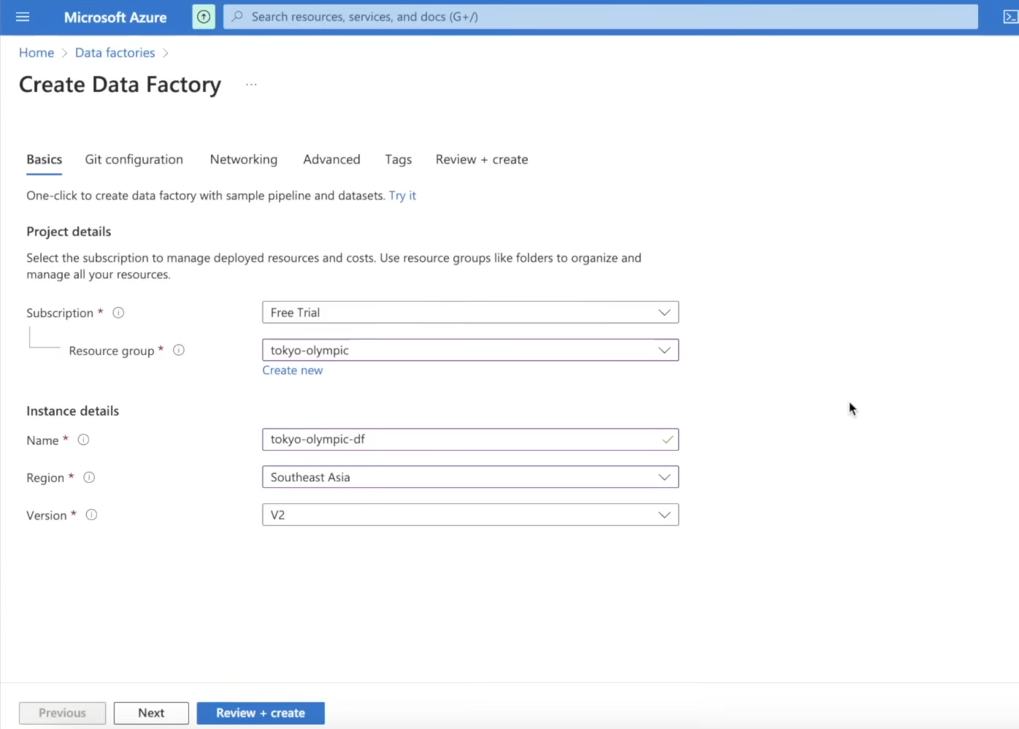

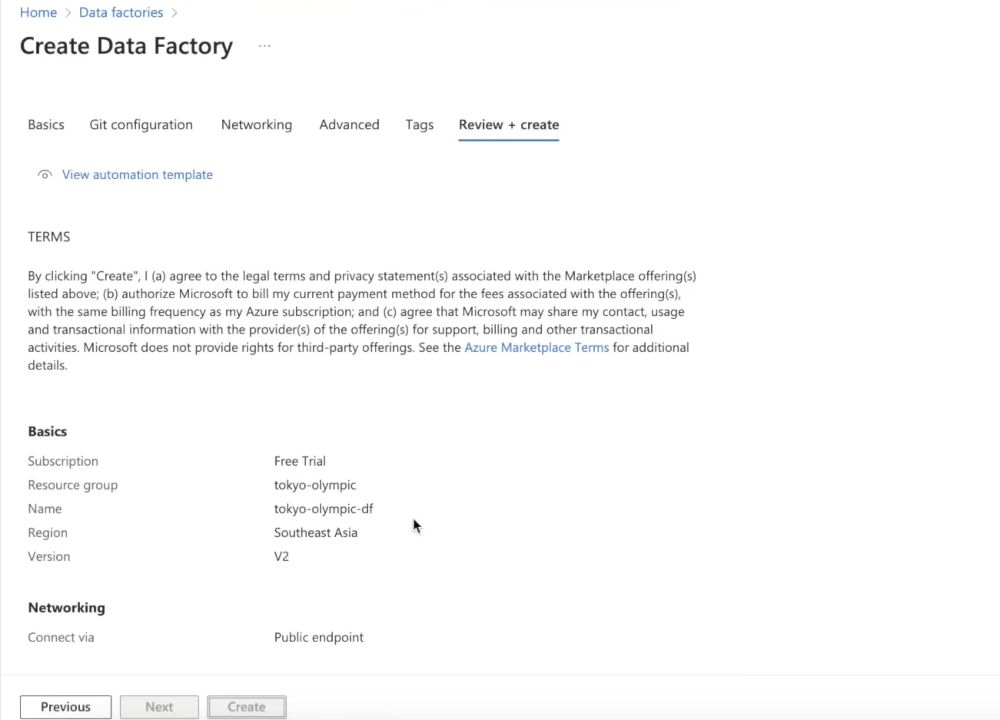

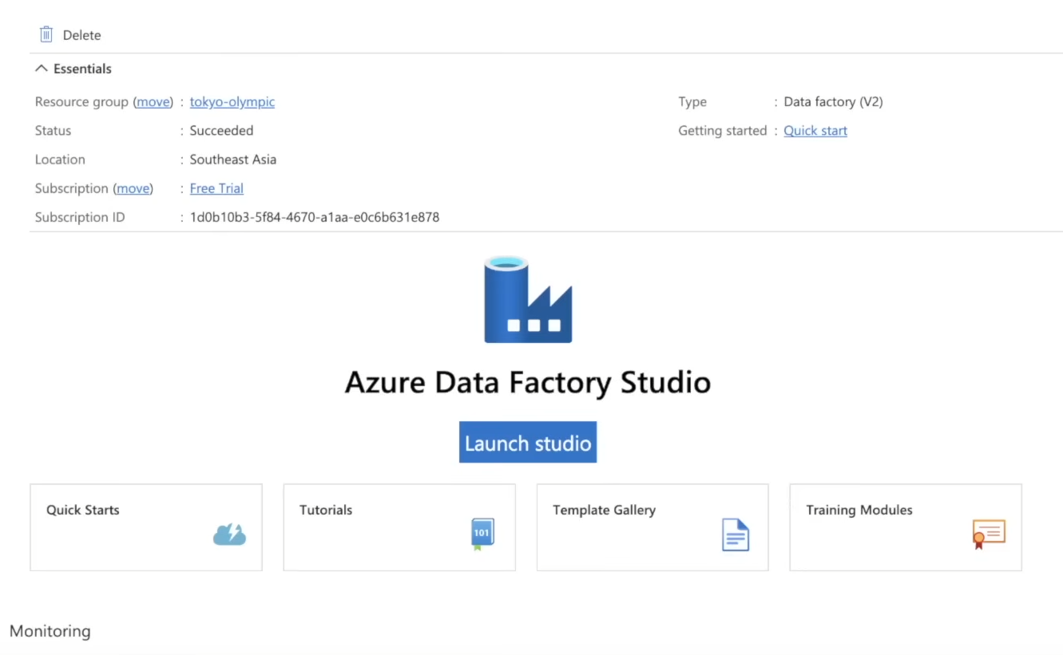

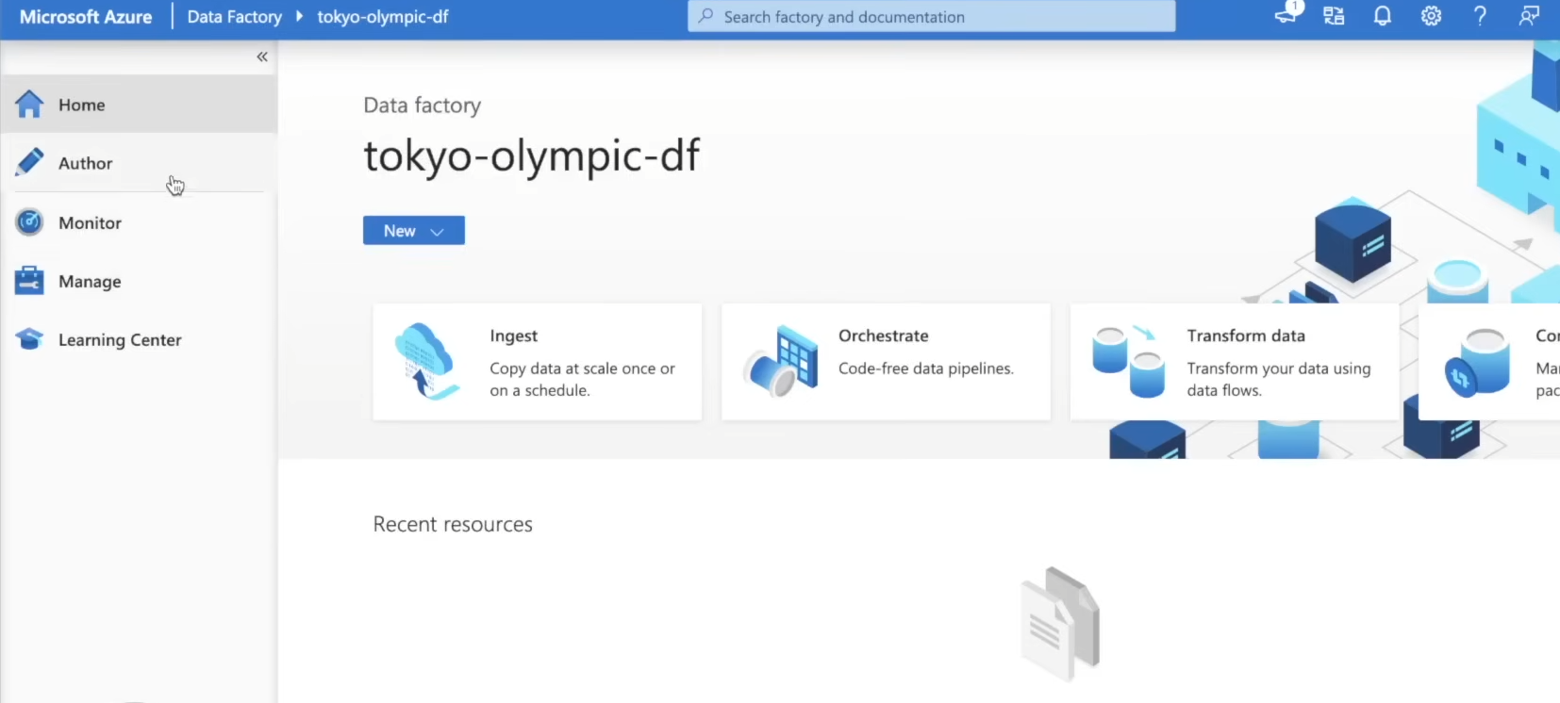

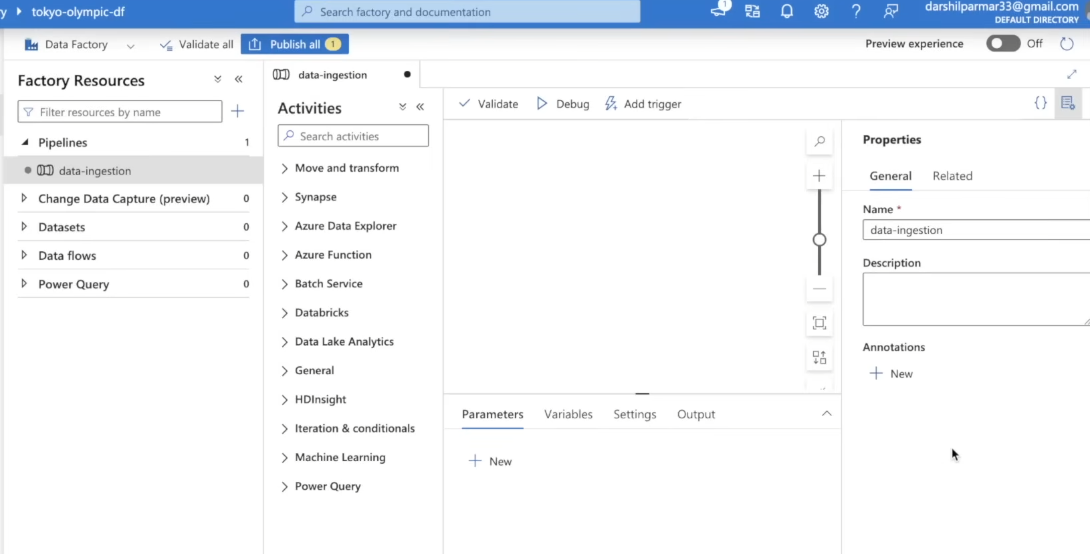

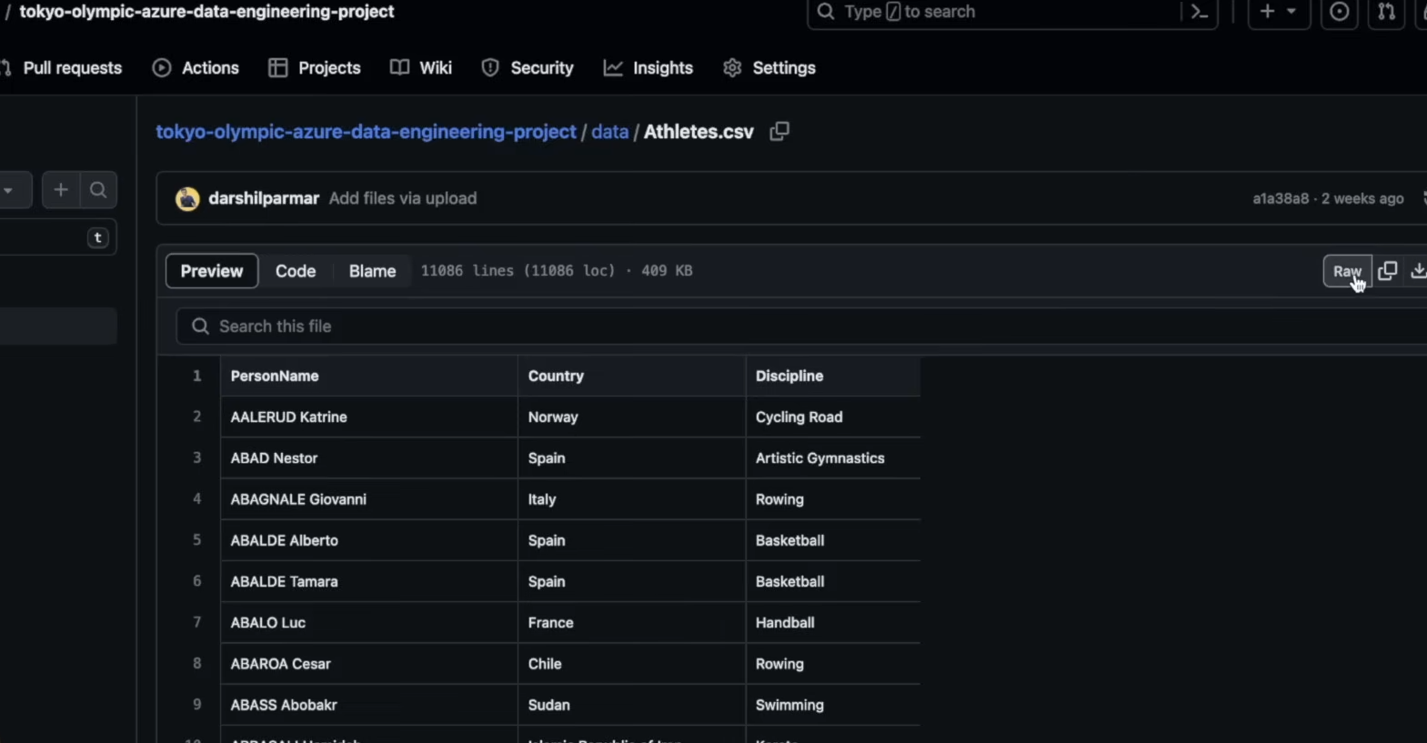

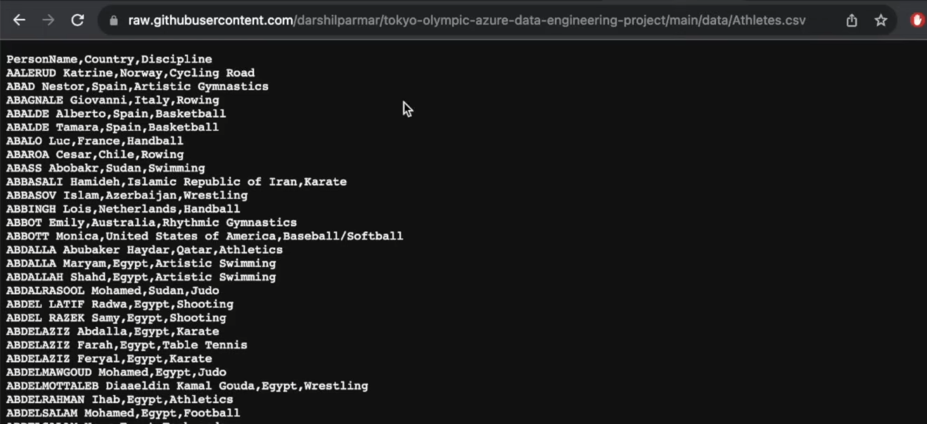

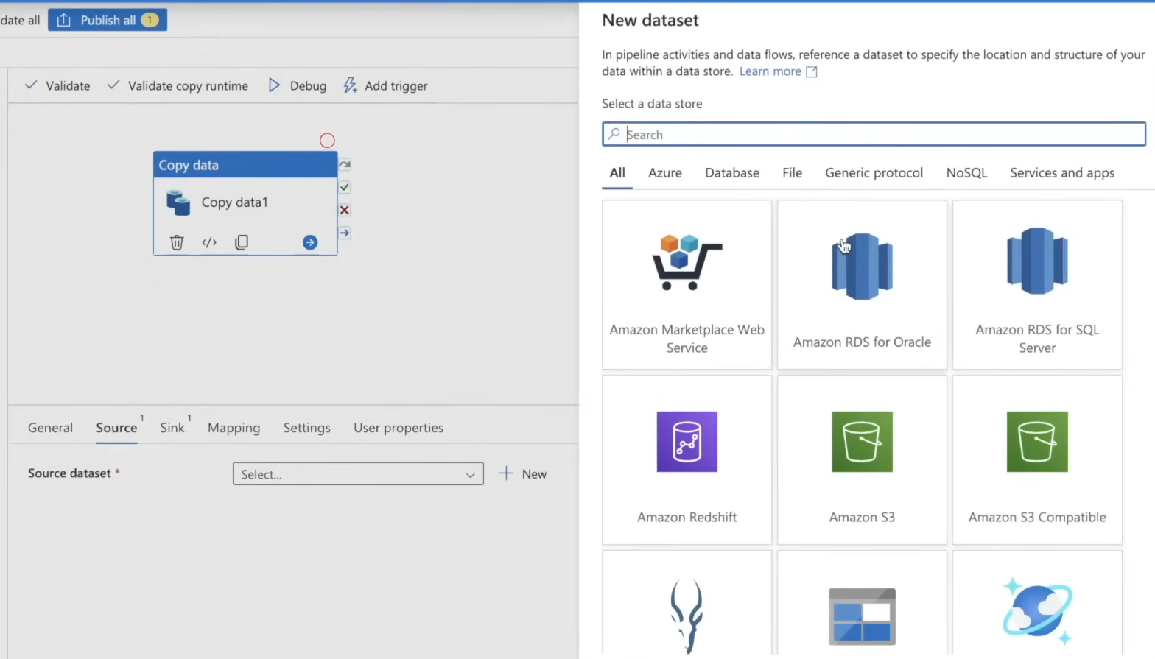

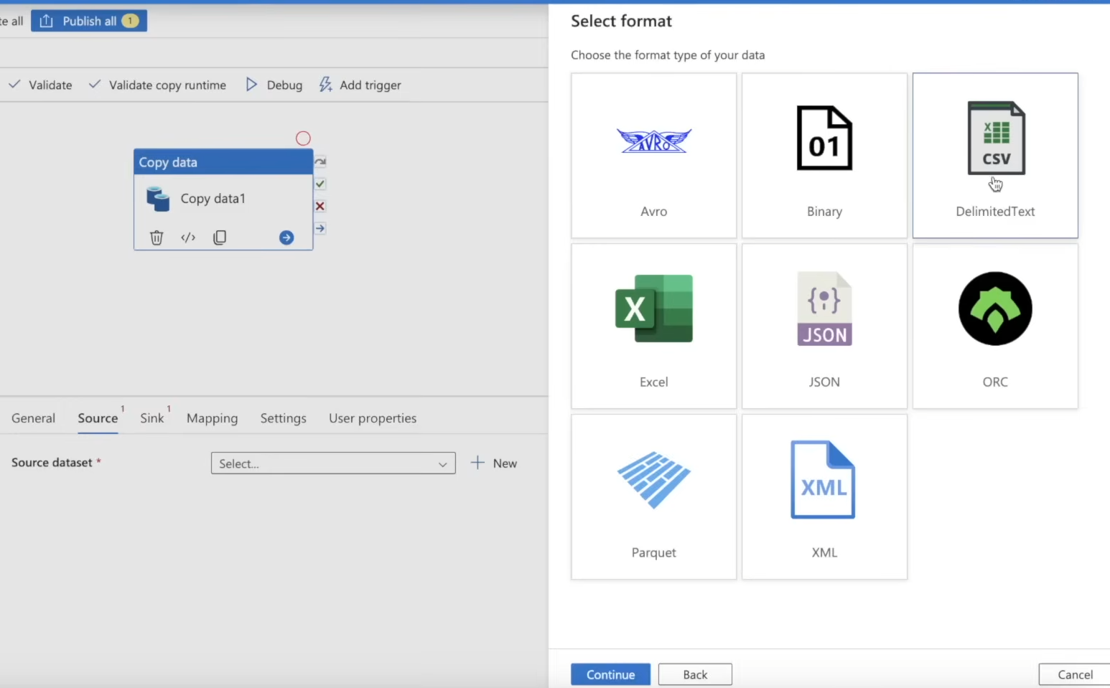

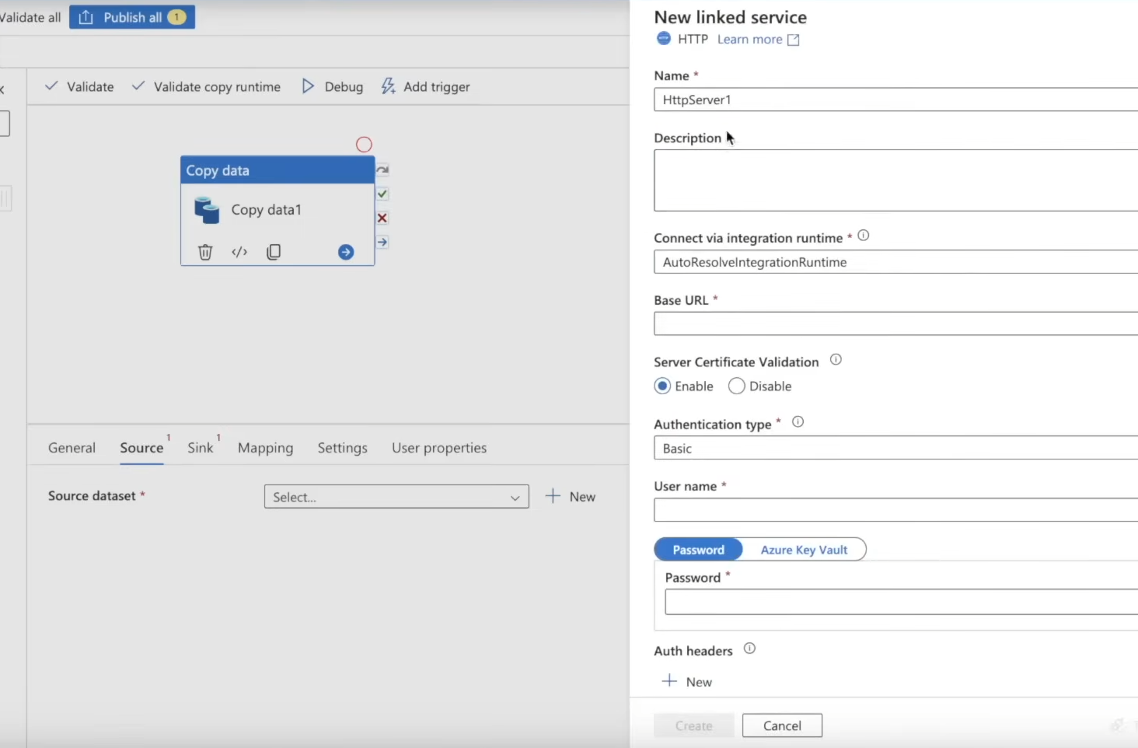

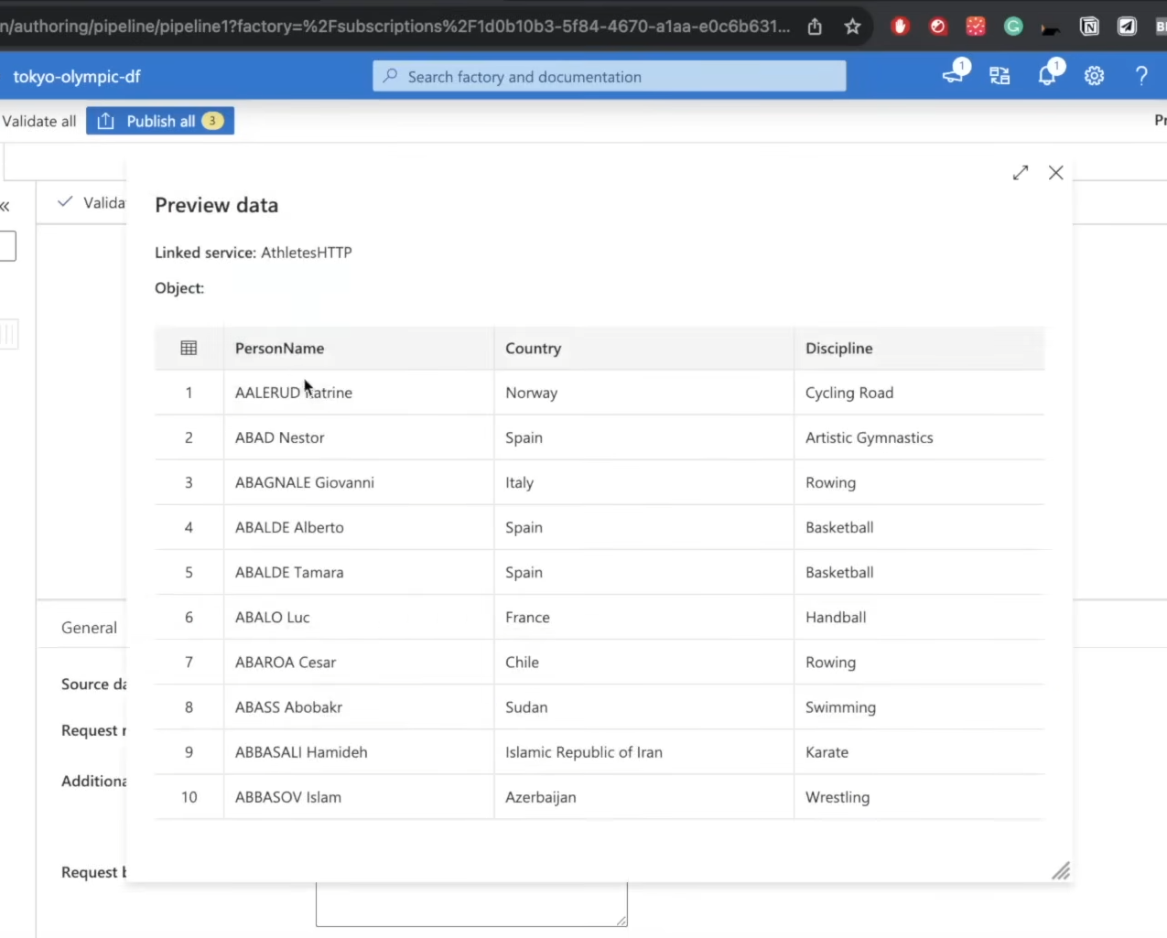

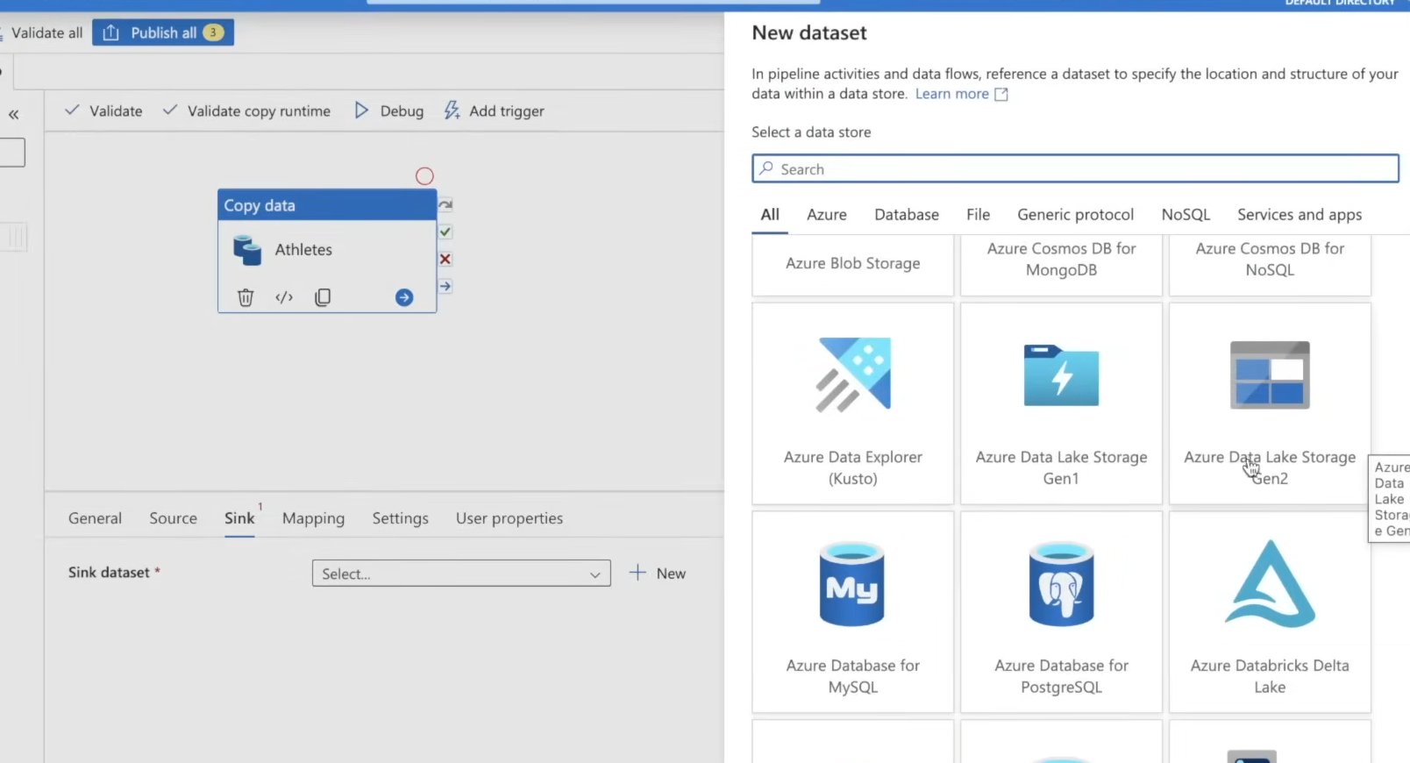

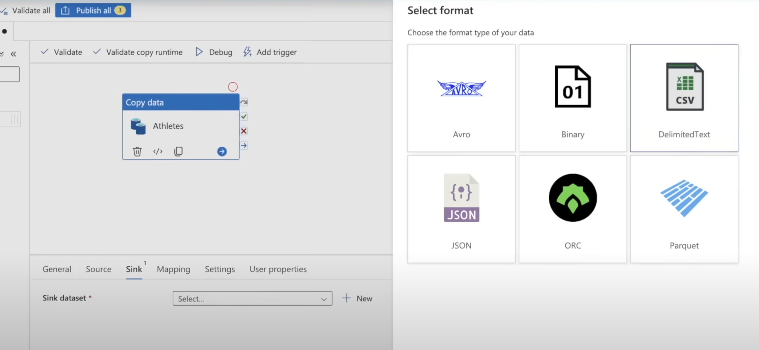

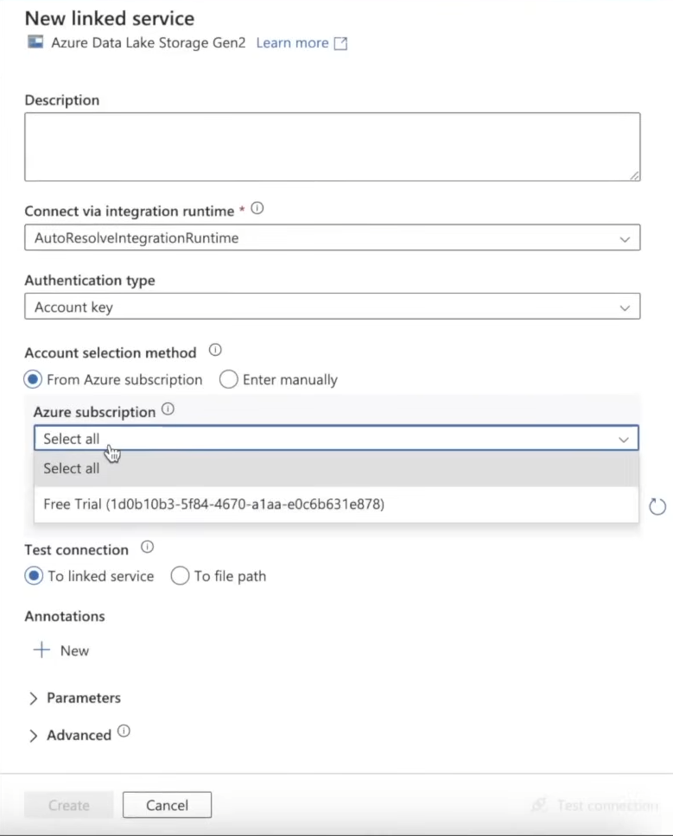

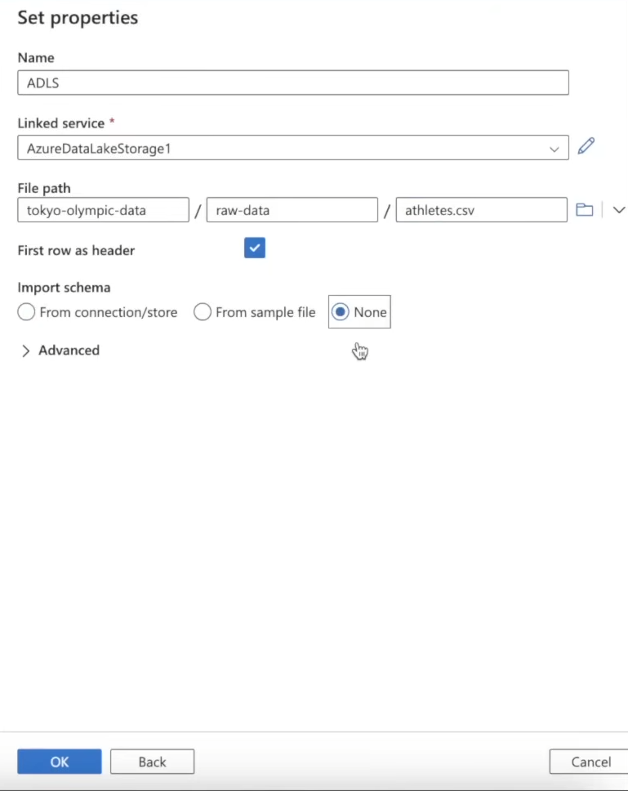

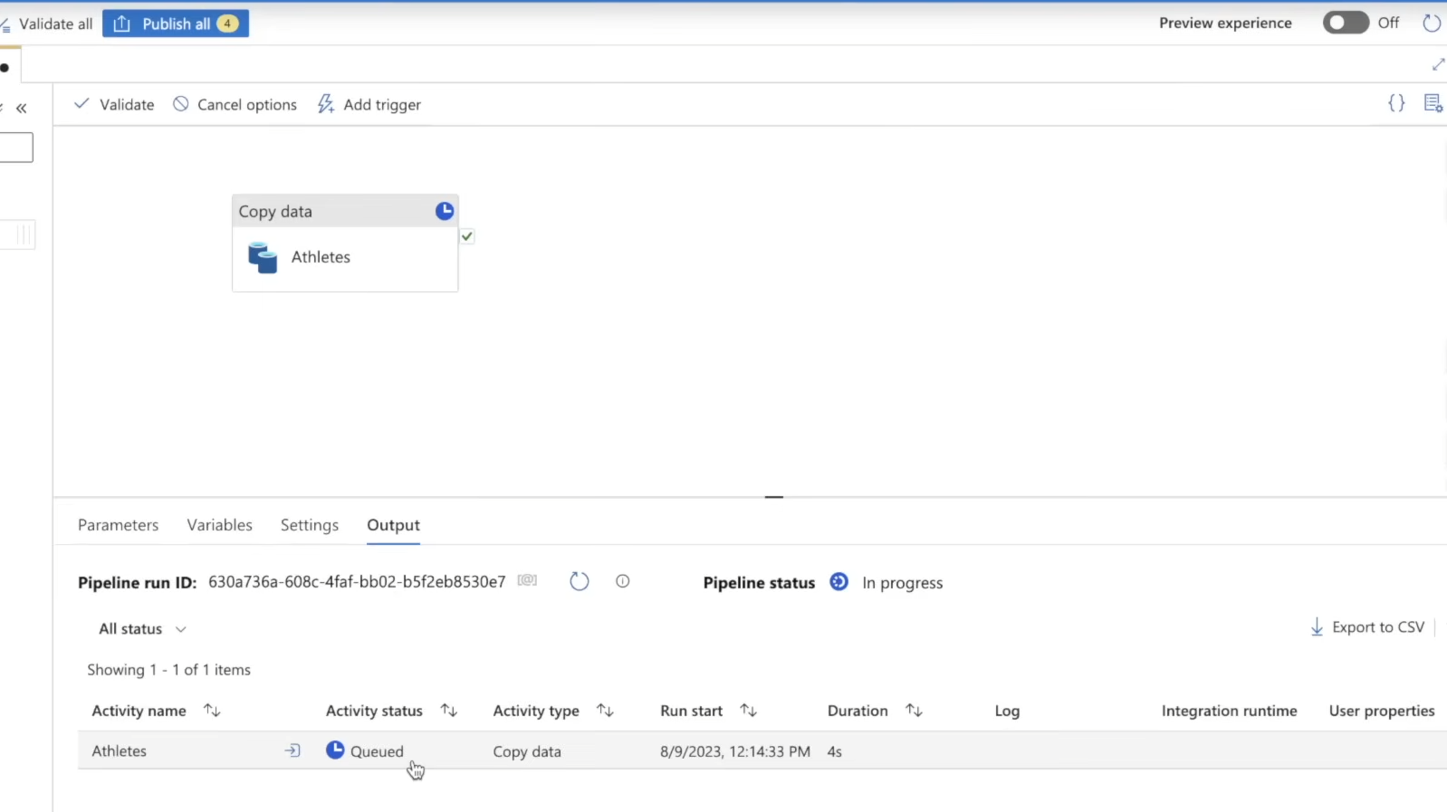

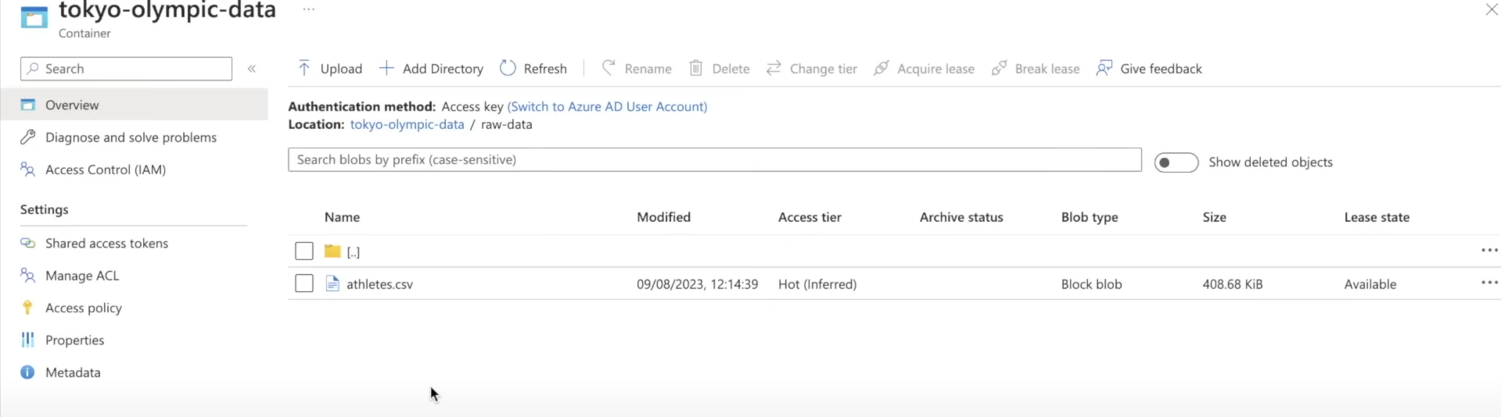

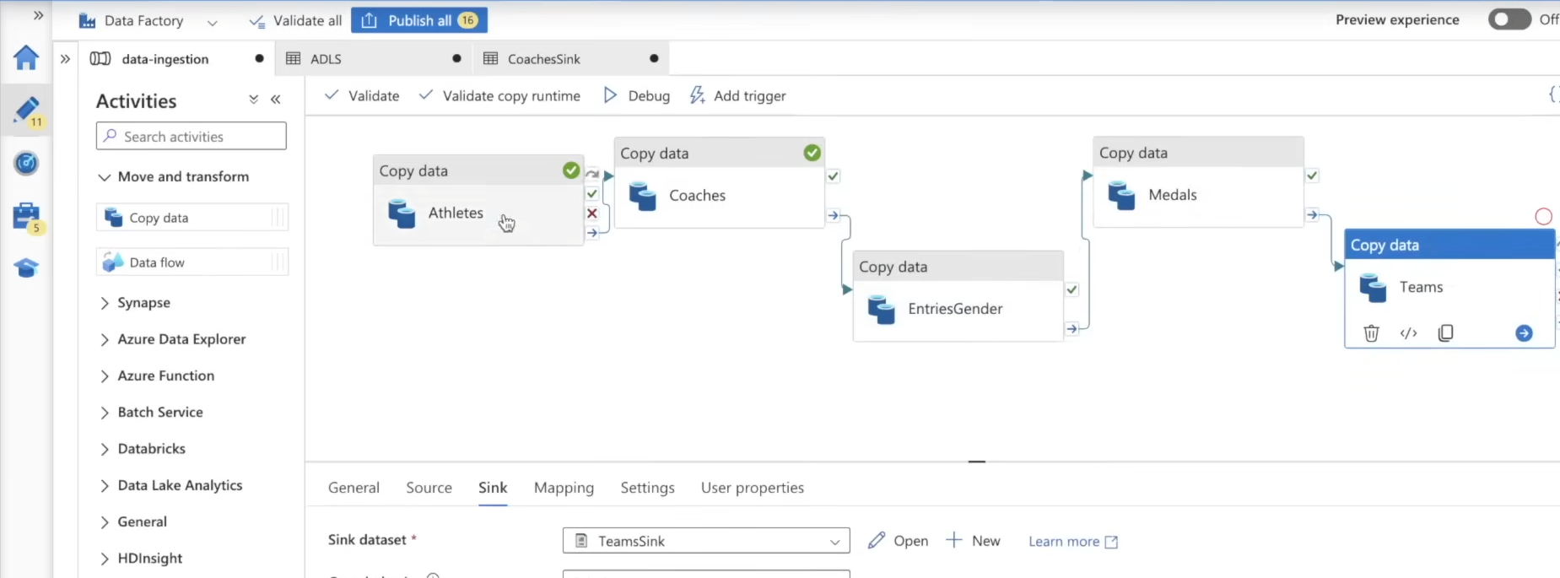

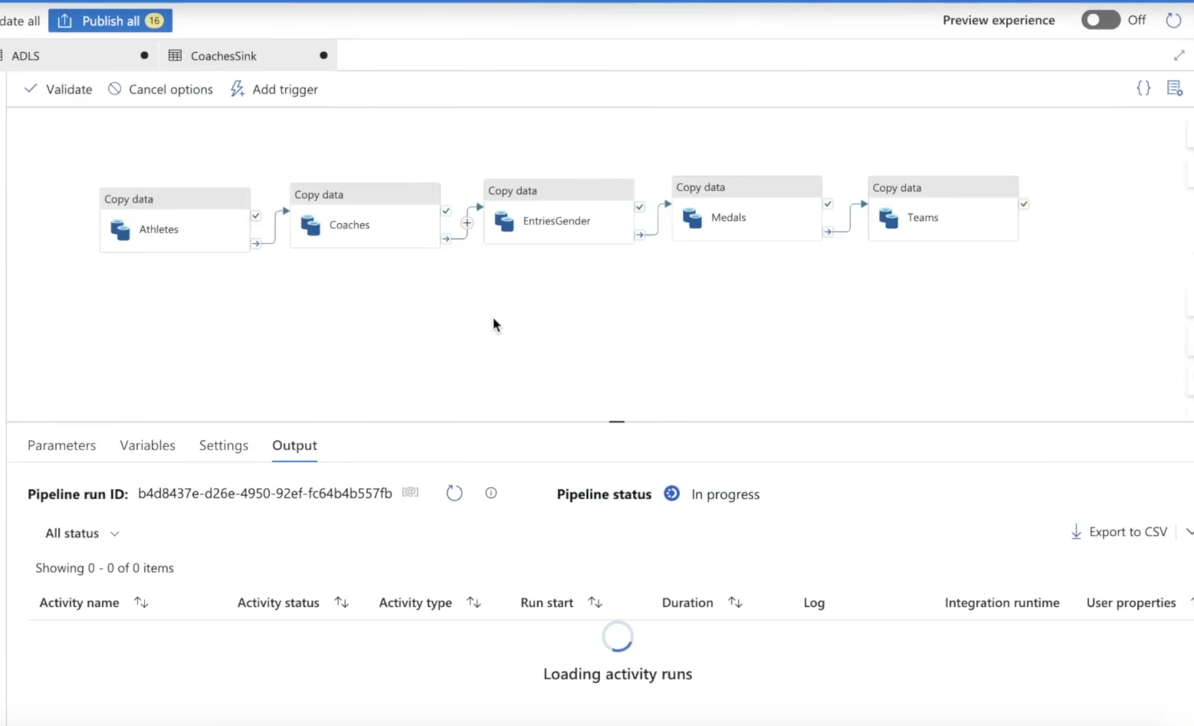

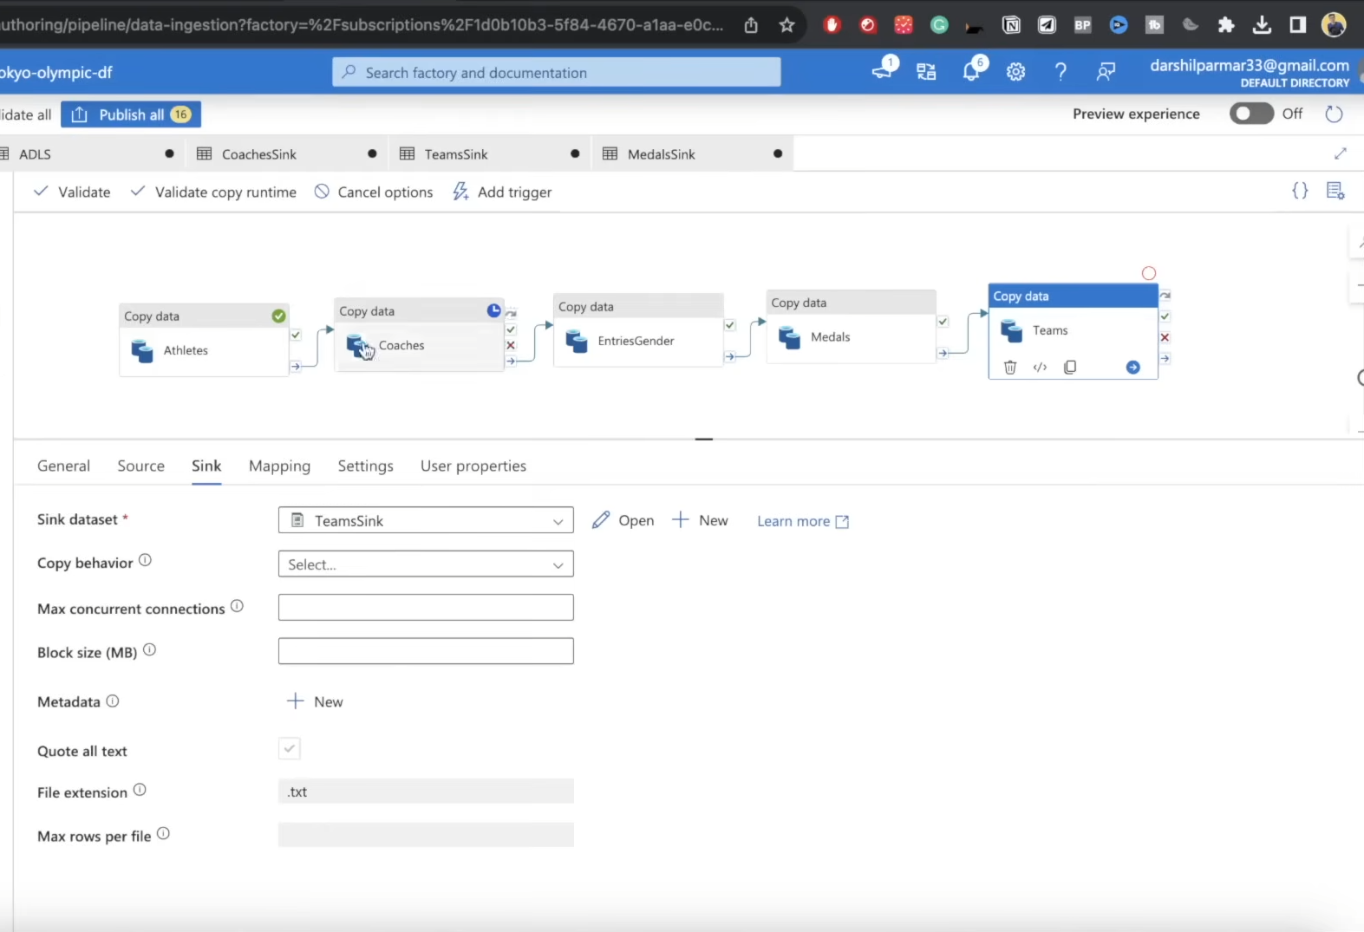

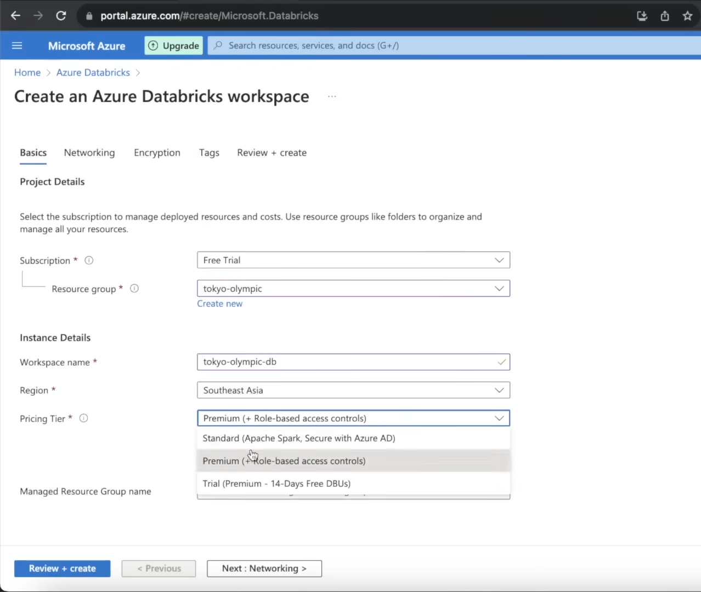

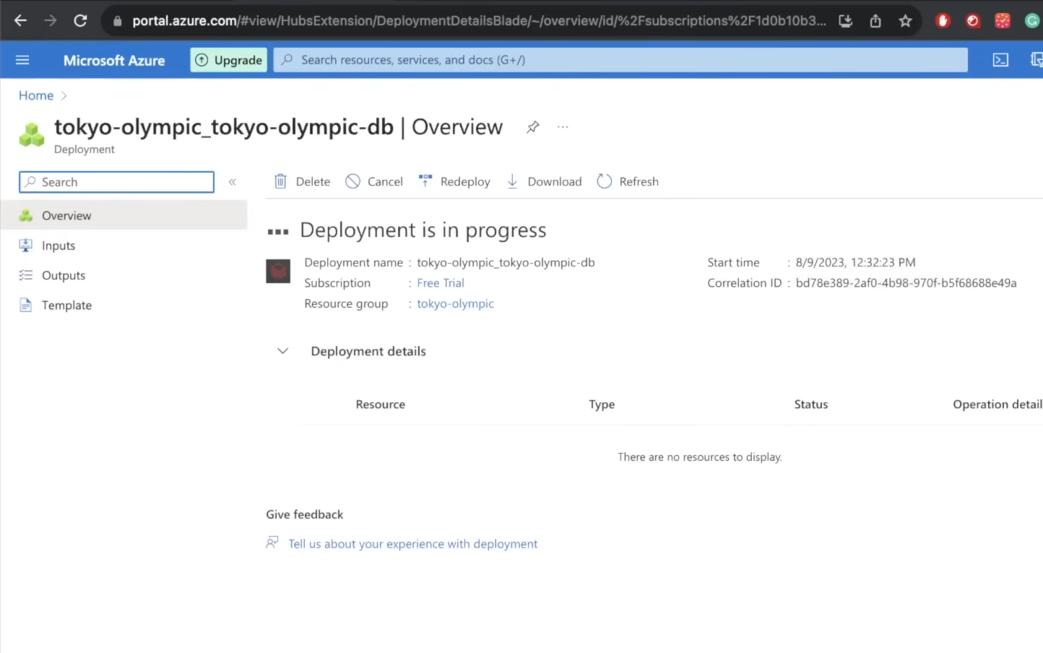

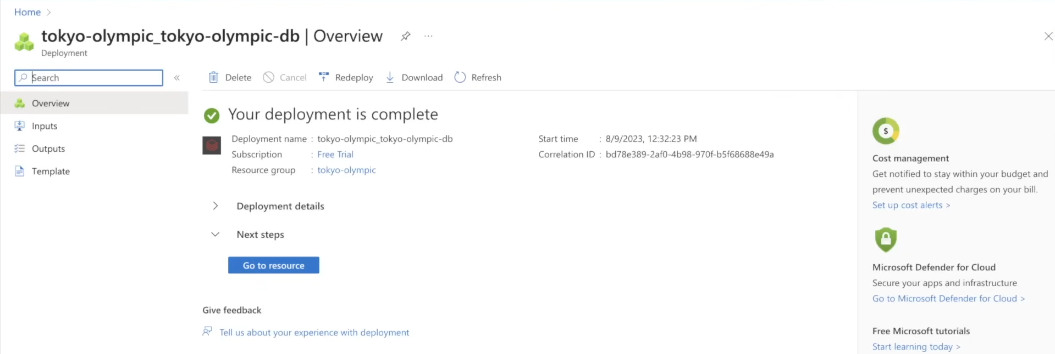

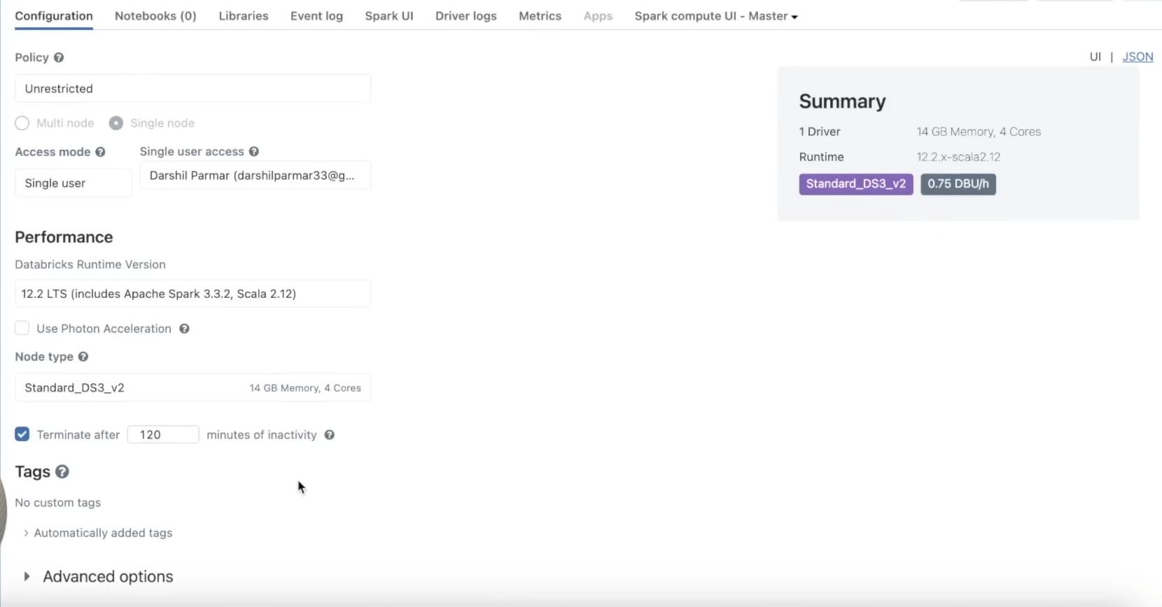

**Service-by-Service Breakdown: The "Why"**

**1. Azure Data Factory (ADF) - The Orchestrator**

* **Why ADF?** It is Azure's native, serverless, and fully managed data integration service. Its primary strength is **orchestration** - connecting to diverse sources (SaaS, databases, files, APIs) and sinking data to various destinations with minimal code.
* **Advantage Over Alternatives (e.g., Writing a custom Python script):**
  + **Managed & Serverless:** No infrastructure to manage. You define the "what," Azure handles the "how."
  + **Visual Interface:** The drag-and-drop UI allows for quickly building and understanding data flows.
  + **Built-in Connectors:** Native, pre-built connectors for hundreds of services (like HTTP, ADLS, SQL DB, etc.) handle authentication and protocol specifics for you.
  + **Monitoring & Alerting:** Built-in monitoring, logging, and retry mechanisms out of the box.
* **Disadvantage of the Alternative (Custom Script):**
  + **Operational Overhead:** You become responsible for the server, logging, error handling, retry logic, and monitoring.
  + **Scalability:** Scaling a custom script requires engineering effort. ADF scales automatically.
  + **Maintenance:** Any change to the source API or destination requires code changes and redeployment.

**2. Azure Data Lake Storage Gen2 (ADLS Gen2) - The Core Storage**

* **Why ADLS Gen2?** It is the foundational storage service for big data analytics on Azure. It's not *just* blob storage; it adds a **hierarchical namespace** (a true directory structure) on top, which is crucial for performance and data organization.
* **Advantage Over Alternative (Azure Blob Storage without Hierarchical Namespace):**
  + **Performance:** Operations like file renames, list operations, and directory management are atomic and orders of magnitude faster. This is critical for big data tools like Spark and Synapse.
  + **Data Organization:** Enforces a logical structure (e.g., raw-data/project/date/file.csv) which is a best practice for data lakes.
  + **Security & ACLs:** Supports POSIX-compliant Access Control Lists (ACLs), allowing for fine-grained security down to the file level.
  + **Optimized for Analytics:** Seamlessly integrates with and is optimized for Azure Databricks, Synapse Analytics, and HDInsight.
* **Disadvantage of the Alternative (Blob Storage):** Using standard blob storage for a data lake leads to slower performance on analytical workloads, clumsy data organization (using prefixes instead of real directories), and less granular security controls.

**3. Azure Databricks - The Transformation Engine**

* **Why Azure Databricks?** It is the premier Spark-based platform on Azure. While Synapse has a Spark pool, Databricks offers a superior developer experience, collaboration features, and performance optimizations (like Photon engine).
* **Advantage Over Alternatives (e.g., Synapse Spark Pools, DIY Spark Cluster on VMs):**
  + **Optimized Spark Runtime:** Databricks provides a highly optimized and maintained version of Spark, often leading to better performance and stability than open-source Apache Spark.
  + **Collaborative Workspace:** Notebooks with real-time collaboration, versioned with Git integration, and a powerful CLI for CI/CD.
  + **Managed Infrastructure:** One-click autoscaling clusters. You get the power of Spark without the pain of cluster management, configuration, and security patching.
  + **Developer Experience:** Superior notebook interface, integrated visualizations, and the dbutils library for easy mounting and secrets management.
* **Disadvantage of the Alternative (Synapse Spark Pools):** While integrated, Synapse Spark pools can feel more constrained in terms of customization and the development experience is generally considered less mature than Databricks. The **DIY Spark Cluster** alternative is a nightmare of configuration, maintenance, and cost-inefficiency.

**4. Azure Synapse Analytics - The Analytics Service**

* **Why Synapse Analytics?** It is the central hub for running T-SQL queries on data in the data lake. Its **serverless SQL pool** is perfect for this project as it allows querying files directly in ADLS Gen2 without loading data into a dedicated data warehouse.
* **Advantage Over Alternatives (e.g., Provisioned Dedicated SQL Pool, Azure SQL Database):**
  + **Cost-Effectiveness (Serverless):** You pay per TB of data scanned, not for constant compute. It's ideal for ad-hoc querying and exploration, as there's no cost when it's idle.
  + **Schema-on-Read:** It uses T-SQL to query Parquet/CSV files directly, applying the schema at query time. This is incredibly flexible and avoids complex ETL to load data first.
  + **Single Pane of Glass:** Synapse Studio integrates Pipelines (ADF), Spark, and SQL into one workspace, providing a unified experience.
* **Disadvantage of the Alternative (Dedicated SQL Pool):** A dedicated pool is a massively parallel processing (MPP) data warehouse that you pay for by the hour. It's overkill and unnecessarily expensive for simple querying of curated data. It's designed for heavy, recurring analytical workloads, not ad-hoc exploration.

**The "One Workflow" Explained**

The workflow is a linear ETL (Extract, Transform, Load) pipeline:

1. **Trigger:** The pipeline is manually triggered (or could be scheduled in ADF).
2. **Extract (ADF):** The Copy Data activity in ADF makes an HTTP request to each pre-defined GitHub RAW CSV URL.
3. **Load to Bronze (ADF -> ADLS):** ADF writes the incoming data stream directly to the raw-data container in ADLS Gen2, preserving the original data exactly as it was from the source. **No transformation happens here.**
4. **Transform (Databricks):**
   * A PySpark notebook is run on an allocated Databricks cluster.
   * The notebook first **mounts** the ADLS Gen2 raw-data path to its distributed file system using the App Registration credentials.
   * It **reads** the CSV files into Spark DataFrames.
   * It applies **transformations:** schema enforcement (casting strings to integers), and any other logic like renaming columns or dropping duplicates.
   * It **writes** the transformed DataFrames as new CSV files to the mounted transform-data path in ADLS Gen2.
5. **Analyze (Synapse):**
   * A user connects Synapse Serverless SQL Pool to the transform-data container.
   * They write standard T-SQL queries using the OPENROWSET function to query the CSV files directly, e.g., SELECT country, SUM(gold) FROM transformed_medals GROUP BY country ORDER BY SUM(gold) DESC.
6. **Visualize (Power BI):** (The final, implied step). Power BI can connect directly to the Synapse Serverless SQL endpoint to import the query results and build interactive dashboards.

**Why This Architecture is Effective**

* **Separation of Concerns:** Each service has a clear, distinct job (orchestration, storage, transformation, analysis). This makes the system modular, easier to debug, and easier to maintain.
* **Scalability:** Every service (ADF, Databricks, ADLS, Synapse Serverless) can independently scale to handle petabytes of data.
* **Cost-Efficiency:** The use of serverless options (ADF, Synapse Serverless) and the ability to shut down Databricks clusters when not in use means you only pay for what you use.
* **Flexibility:** The data is stored in an open format (CSV/Parquet) in the data lake, making it accessible to a wide variety of tools, not just Azure services. This avoids vendor lock-in at the storage layer.

**Step-by-Step Explanation of the PySpark Code & Service Integration**

This section covers the workflow *after* the data has been ingested into the raw-data container by Azure Data Factory.

**Phase 1: Setting Up the Transformation Engine (Azure Databricks)**

**Step 1: Create a Databricks Workspace**

* **Action:** In the Azure Portal, create a new Azure Databricks service. This provides the collaborative environment where you will write and execute your code.
* **Why:** It's the managed platform for running Apache Spark clusters and notebooks without managing the underlying infrastructure.

**Step 2: Launch the Workspace & Create a Cluster**

* **Action:** Click "Launch Workspace" to open the Databricks environment in a new tab. Inside, create a new "cluster." This cluster is a set of computational resources (virtual machines) that will execute your PySpark code.
* **Configuration:** For this tutorial, a **"Single Node"** cluster is sufficient. It's cheaper and adequate for this dataset size. In production, you would use a multi-node cluster for distributed processing.

**Step 3: Create a Notebook**

* **Action:** Create a new Python notebook and attach it to the cluster you just created. This notebook is where you will write all your PySpark code.

**Phase 2: Connecting Databricks to Data Lake (The Mounting Process)**

This is a critical security and connectivity step. Instead of passing credentials every time we read a file, we "mount" the storage account to Databricks, making it appear like a local file system.

**Step 4: Azure Active Directory (App Registration) Setup**

* **Action:** In the Azure Portal, go to Azure Active Directory > App Registrations > Create a new registration (e.g., olympic-app).
* **Goal:** Create a service identity (Service Principal) that Databricks will use to access the Data Lake.
* **Output:** You get three crucial pieces of information:
  1. **Application (Client) ID**
  2. **Directory (Tenant) ID**
  3. **A Client Secret** (created under "Certificates & secrets")

**Step 5: Grant Permissions to the App**

* **Action:** Go to your Storage Account (tokyo-olympic-data). Under **Access Control (IAM)**, add a role assignment.
* **Role:** Assign the Storage Blob Data Contributor role to the App Registration (olympic-app).
* **Why:** This grants the app the necessary permissions (read, write, delete) to act on the blob data inside your storage account's containers.

**Step 6: The Mounting Code in Databricks Notebook**

* **Action:** Run the following code in a notebook cell. This code uses the app's credentials to create a secure connection.

python

# Define the secrets (In production, use Databricks Secrets scope!)

client_id = "your-client-id-from-step-4"

tenant_id = "your-tenant-id-from-step-4"

client_secret = "your-client-secret-from-step-4"

# Configure the authentication

configs = {

"fs.azure.account.auth.type": "OAuth",

"fs.azure.account.oauth.provider.type": "org.apache.hadoop.fs.azurebfs.oauth2.ClientCredsTokenProvider",

"fs.azure.account.oauth2.client.id": client_id,

"fs.azure.account.oauth2.client.secret": client_secret,

"fs.azure.account.oauth2.client.endpoint": f"https://login.microsoftonline.com/{tenant_id}/oauth2/token"

}

# Define the mount point path and the source location

mount_point = "/mnt/olympicdata"

source_url = "abfss://tokyo-olympic-data@storageaccountname.dfs.core.windows.net/" # Replace with your container & storage account name

# Create the mount

dbutils.fs.mount(

source = source_url,

mount_point = mount_point,

extra_configs = configs)

* **Outcome:** After running this, you can access your entire storage container via the path /mnt/olympicdata. For example, your raw data is now at /mnt/olympicdata/raw-data/athletes.csv.

**Phase 3: The PySpark Transformation Code**

Now we write the core data engineering logic.

**Step 7: Read Raw Data into Spark DataFrames**

* **Action:** Use the Spark read API to load the CSV files from the mounted location into DataFrames. A DataFrame is a distributed collection of data organized into named columns (like a spreadsheet table in memory).

python

# Read the athletes.csv file from the raw-data directory

athletes_df = spark.read \

.option("header", "True") \ # Treat the first row as header

.csv("/mnt/olympicdata/raw-data/athletes.csv")

# Do the same for other files

coaches_df = spark.read.option("header", "True").csv("/mnt/olympicdata/raw-data/coaches.csv")

entries_gender_df = spark.read.option("header", "True").csv("/mnt/olympicdata/raw-data/entriesgender.csv")

medals_df = spark.read.option("header", "True").csv("/mnt/olympicdata/raw-data/medals.csv")

teams_df = spark.read.option("header", "True").csv("/mnt/olympicdata/raw-data/teams.csv")

**Step 8: Apply Transformations**

* **Action:** Perform data cleaning and preparation. A common issue is numbers being read as strings. We fix this by casting columns to the correct data type.

python

# Example: Cast the 'Female', 'Male', and 'Total' columns from string to integer

from pyspark.sql.types import IntegerType

from pyspark.sql.functions import col

entries_gender_transformed_df = entries_gender_df \

.withColumn("Female", col("Female").cast(IntegerType())) \

.withColumn("Male", col("Male").cast(IntegerType())) \

.withColumn("Total", col("Total").cast(IntegerType()))

# Alternatively, use schema inference (often faster for well-formatted data)

medals_transformed_df = spark.read \

.option("header", "True") \

.option("inferSchema", "True") \ # Spark automatically guesses the best data types

.csv("/mnt/olympicdata/raw-data/medals.csv")

* **Other common transformations:** Filtering out null rows, renaming columns, joining DataFrames, and creating new calculated columns.

**Step 9: Write Transformed Data Back to Data Lake**

* **Action:** Write the transformed DataFrames back to the Data Lake, but now in the transform-data directory (the Silver layer).

python

# Write the transformed athletes data to the transform-data directory

athletes_df.write \

.mode("overwrite") \ # Overwrite the data if it already exists

.option("header", "True") \

.csv("/mnt/olympicdata/transform-data/athletes")

# Write the casted entries_gender data

entries_gender_transformed_df.write \

.mode("overwrite") \

.option("header", "True") \

.csv("/mnt/olympicdata/transform-data/entriesgender")

* **Note:** Spark writes data as a directory of partitioned files (e.g., part-00001-...csv). This is normal and optimal for distributed systems.

**Phase 4: Analysis with Azure Synapse Analytics**

**Step 10: Query Transformed Data with Serverless SQL Pool**

* **Action:** Open Azure Synapse Analytics. Use the "Serverless SQL pool" which requires no setup. Write a SQL query to analyze the data directly from the transform-data directory.

sql

-- This query runs directly on the CSV files in the data lake

SELECT TOP 10 *

FROM OPENROWSET(

BULK 'https://storageaccountname.dfs.core.windows.net/tokyo-olympic-data/transform-data/medals/*.csv',

FORMAT = 'CSV',

PARSER_VERSION = '2.0',

HEADER_ROW = TRUE

) AS [result]

ORDER BY result.Gold DESC;

* **How it Works:** The OPENROWSET function allows T-SQL to perform schema-on-read queries against the CSV files. Synapse automatically interprets the file structure.

**Step 11: Create Views for Easier Access**

* **Action:** To avoid writing the long OPENROWSET query every time, you can create a View over the data.

sql

CREATE VIEW GoldMedals AS

SELECT *

FROM OPENROWSET(

BULK 'https://storageaccountname.dfs.core.windows.net/tokyo-olympic-data/transform-data/medals/*.csv',

FORMAT = 'CSV',

PARSER_VERSION = '2.0',

HEADER_ROW = TRUE

) AS [result];

-- Now you can simply query:

-- SELECT * FROM GoldMedals ORDER BY Gold DESC;

**Phase 5: Visualization (The Final Step)**

**Step 12: Connect Power BI to Synapse**

* **Action:** In Power BI Desktop, get data from "Azure Synapse Analytics SQL." Provide the Synapse workspace connection details.
* **Outcome:** You can now import the query from Step 10 or directly query the View created in Step 11.
* **Result:** Build interactive reports and dashboards (e.g., a bar chart showing countries with the most gold medals, a pie chart of gender distribution in disciplines) without moving the data out of the data lake. Synapse serves as the query engine, and Power BI is the visualization tool.

**Summary of the Data Flow**

1. **ADF pulls** data from GitHub -> **ADLS (Raw/Bronze)**.
2. **Databricks reads** from Raw -> **transforms data in memory** -> **writes** to ADLS (Transformed/Silver).
3. **Synapse queries** the Transformed data directly via SQL -> **sends results to Power BI**.
4. **Power BI** creates **visualizations and dashboards**.